**Front End Assignments**

**1.HTML**

**1.** **Write a program to design semantic and non - semantic tags with web page form layout to get this desired output ?**

**My output:**

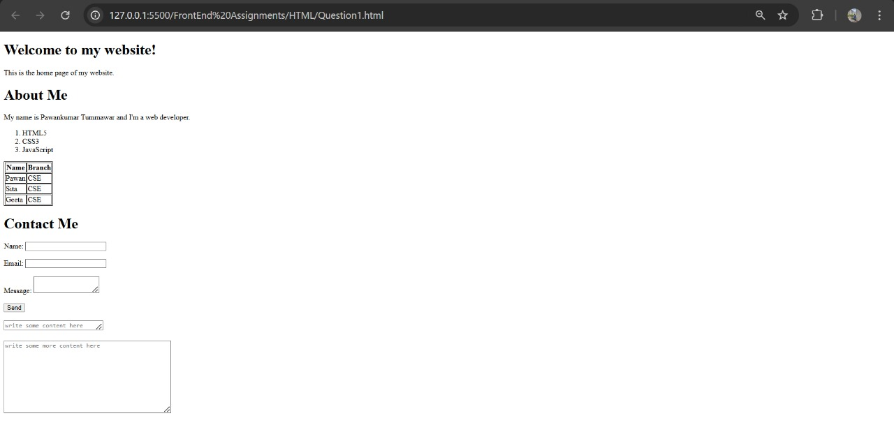

**2.Write a program to display the menucard using table and using inline css properties for color?**

**My output:**

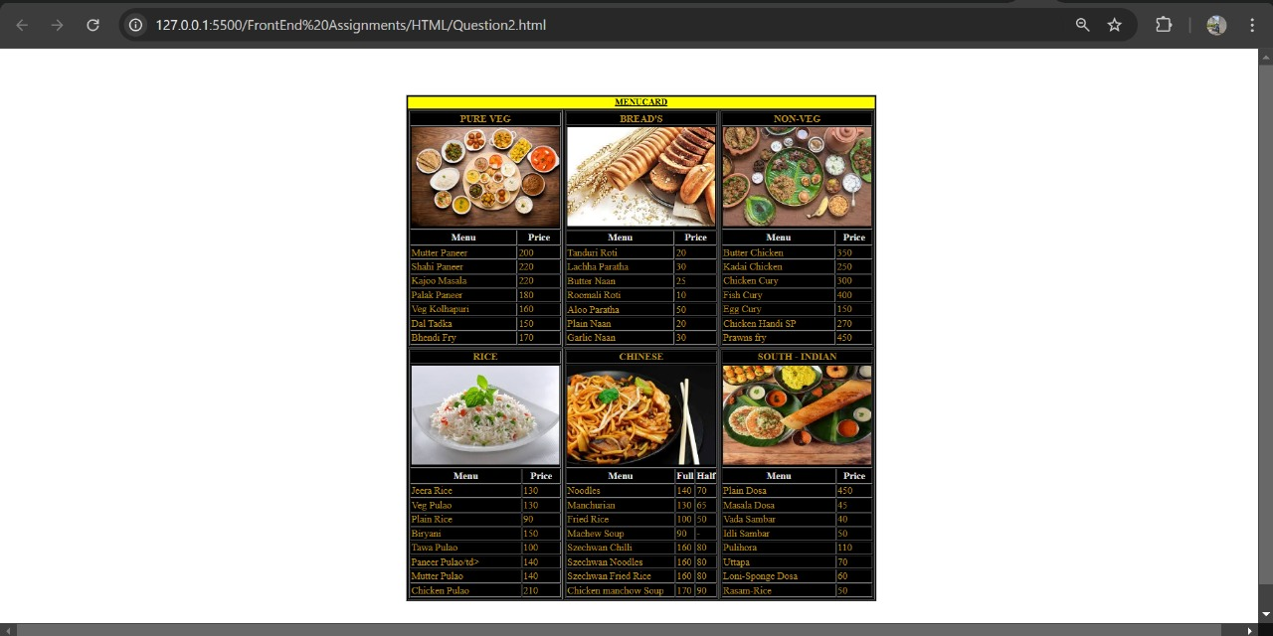

**3.Write a program to show all form input controls in HTML5 as given below?**

**My output:-**

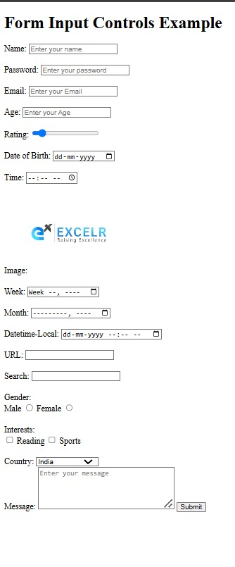

**2.CSS**

**4.design flipkart login page?**

**My output:-**

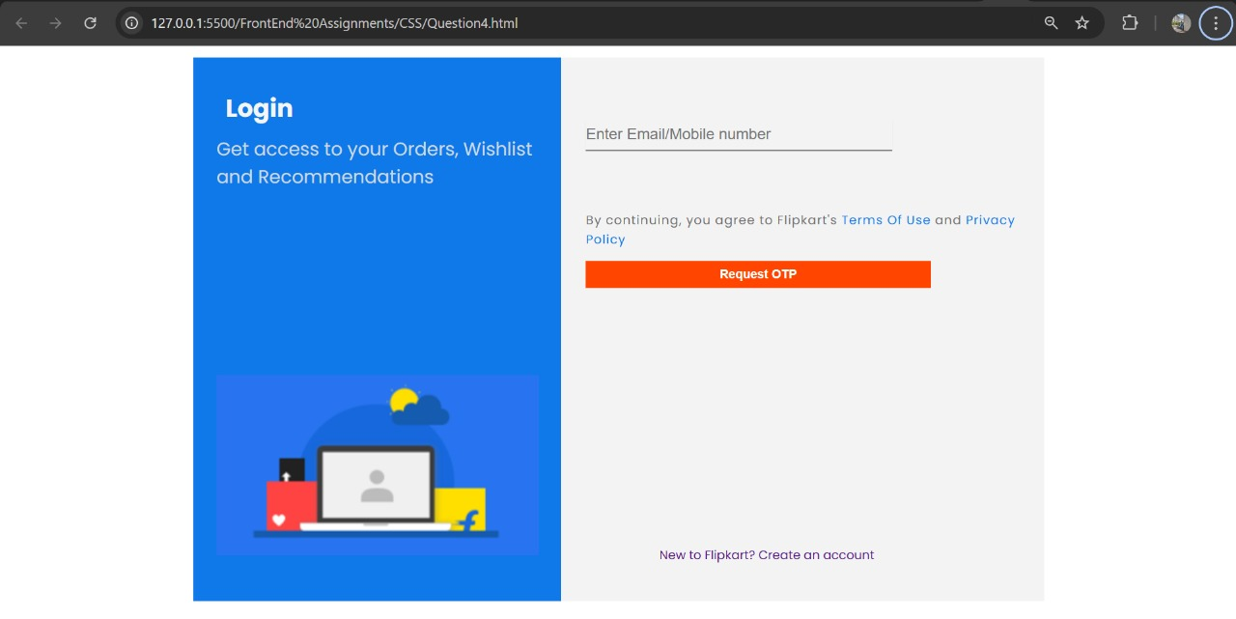

**5.Write a program and display all flexbox properties?**

**My output:-**

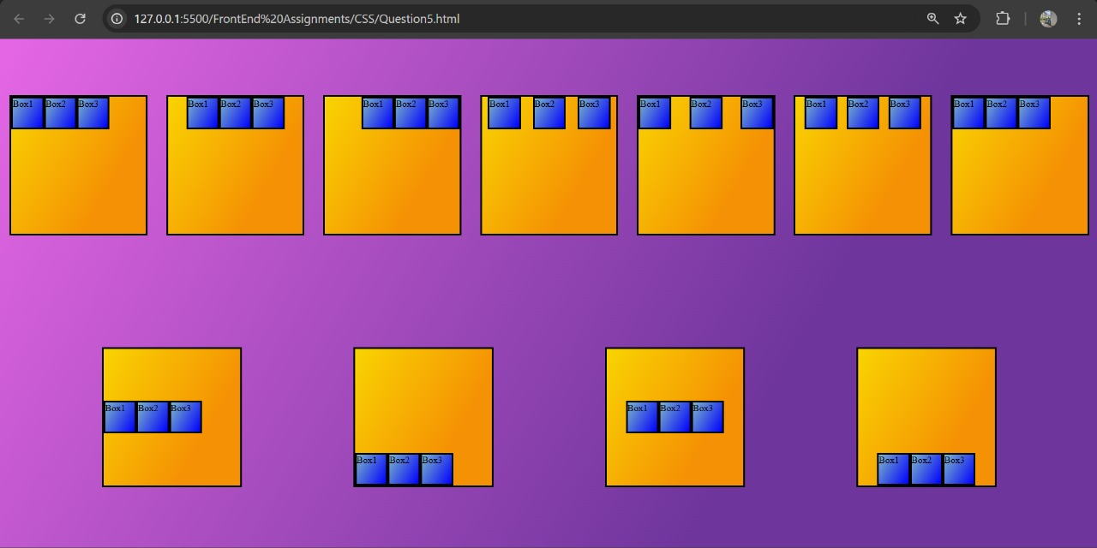

**6.Write a program to design standard web layout using GRID?**

**My output:-**

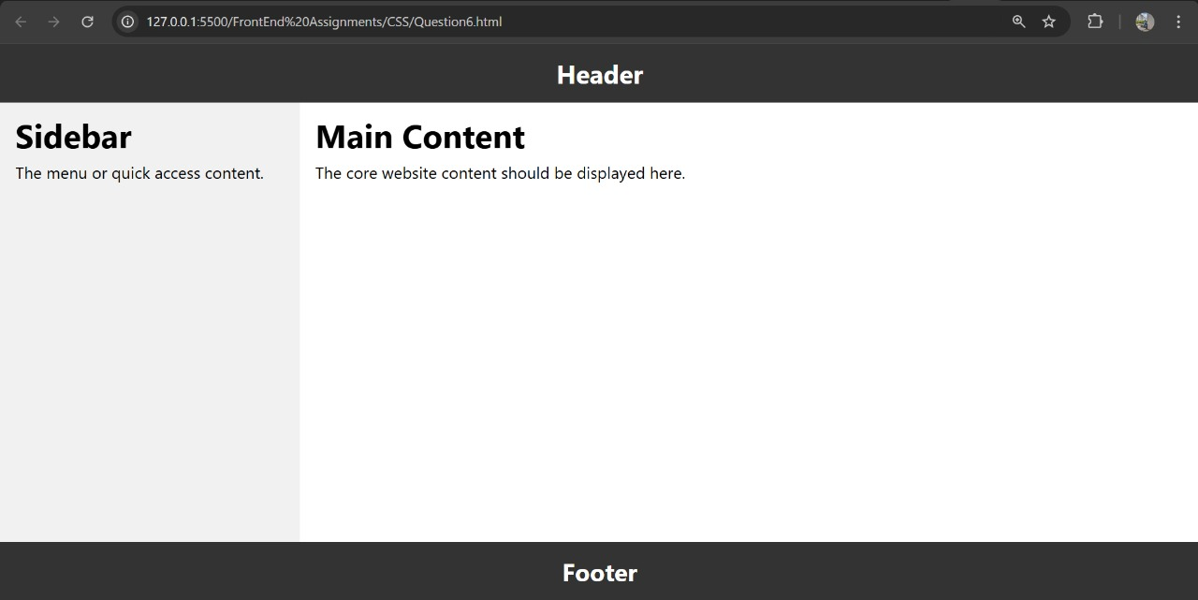

**3.Java Script**

**7.Write a program to demonstrate JavaScript loops, operators and conditions?**

My output:-

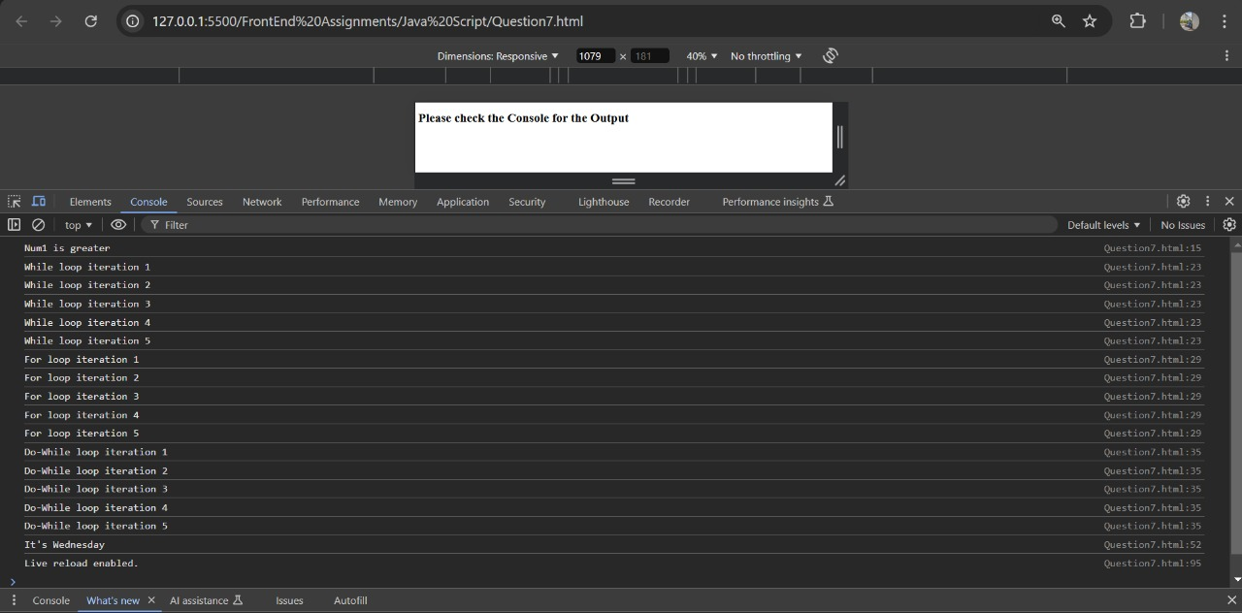

**8. Write a program to create bulb design using dom model and provide functionality using function?**

**1)condition one : if click on button ask to color and display on bulb**

**2)condition two:if click off button display the bulb color white**

**My Output:-**



